**DISTANCE MEASURING DEVICE USING AN ULTRASONIC RANGE FINDER**

**Mini–Project**

**Engineering Physics I**

**First Year**

**Subham Patel**

19ET1006

I/3

2019-20 (I)

**Total Marks Faculty Signature**

**DISTANCE MEASURING DEVICE USING AN ULTRASONIC RANGE FINDER**

Subham Patel

1

Department of Engineering Sciences,

Ramrao Adik Institute of Technology,

Nerul, Navi Mumbai, India

Email id:sp.octone@gmail.com;

**Abstract:** This device can be used to find the distance to an object, or to detect when something is near the sensor like a motion detector. Since this device offers non-contact range detection with high accuracy and stable readings in an easy-to-use package, it will be ideal for projects involving navigation, object avoidance, and home security. Because they use sound to measure distance, they work just as well in the dark as they do in the light. [The ultrasonic range finder I’ll be using](http://www.amazon.com/gp/product/B00F167T2A/ref=as_li_qf_sp_asin_il_tl?ie=UTF8&camp=1789&creative=9325&creativeASIN=B00F167T2A&linkCode=as2&tag=circbasi-20&linkId=TB5LMUTUVTY5BSU6) in this project is the HC-SR04, which can measure distances from 2 cm up to 400 cm with an accuracy of ±3mm[1]. This sensor measures the time it takes the ultrasonic pulse transmitted by it to travel to an object and back with the help of which we can calculate the distance between the sensor and the object. The distance once calculated using the Arduino will be displayed on a 16x2 LCD display.

**Keywords:** LCD, Arduino, Sensor, Breadboard, Ultrasonic

# Introduction

Ultrasonic range finders measure distance by emitting a pulse of ultrasonic sound that travels through the air until it hits an object. When that pulse of sound hits an object, it’s reflected off the object and travels back to the ultrasonic range finder. The ultrasonic range finder measures how long it takes the sound pulse to travel in its round trip journey from the sensor and back. It then sends a signal to the Arduino with information about how long it took for the sonic pulse to travel.

## Why/When to use Ultrasonic Sensors?

1. Ideally suited to accurate, automatic distance measurement in normal and difficult environments.
2. Particularly suitable for environments where optical sensors (e.g. LASER) are unusable such as smoke, dust and similar.
3. Very accurate, stable and can be used over large ranges.

Ultrasonic sensors can measure the following parameters without contacting the medium to be measured:

1. Distance
2. Level
3. Diameter
4. Presence
5. Position

Because of all the factors above the device built for this mini-project has a wide range of uses ranging from general use to industrial applications. [2]

# Experimental

# How it works

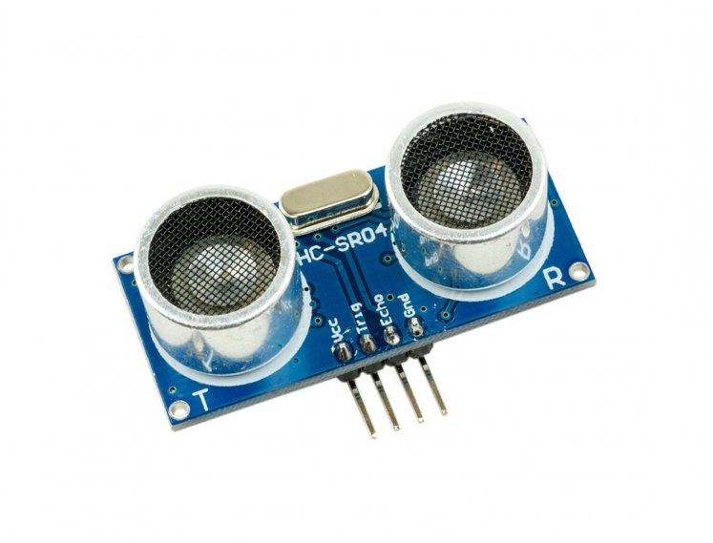

The HC-SR04 ultrasonic range finder has four pins:

VCC, Trig, Echo, and GND.

The VCC pin supplies the power to generate the ultrasonic pulses. The GND pin is connected to ground. The Trig pin is where the Arduino sends the signal to start the ultrasonic pulse. The Echo pin is where the ultrasonic range finder sends the information about the duration of the trip taken by the ultrasonic pulse to the Arduino.

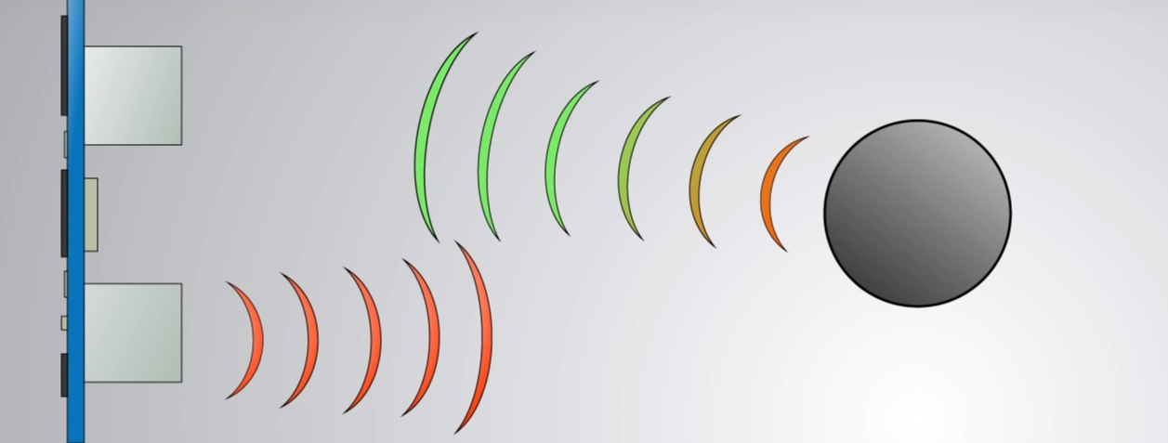

In the ultrasonic range finder, there is a transmitting transducer and receiving transducer. The transmitting transducer converts an electrical signal into the ultrasonic pulse, and the receiving transducer converts the reflected ultrasonic pulse back into an electrical signal.

In order to generate the ultrasound you need to set the Trig on a High State for 10 µs. That will send out 8 pulses of ultrasonic sound at a frequency of 40 KHz from the transmitting transducer which will travel at the speed of sound and it will be received in the Echo pin. When the pulse hits the receiving transducer, the Echo pin outputs a high voltage signal.

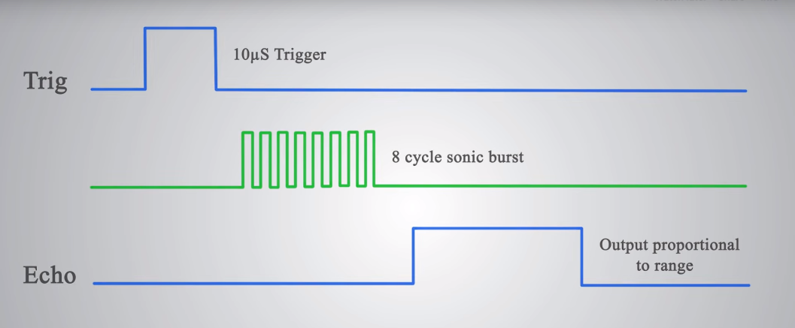

Knowing the time it takes the ultrasonic pulse to travel back and forth to the object, and also knowing the speed of sound, the Arduino can calculate the distance to the object. The formula relating the speed of sound, distance, and time traveled is:

speed = \frac{distance}{time} 

Rearranging this formula, we get the formula used to calculate distance:

distance = speed \ \times \ time 

The time variable is the time it takes for the ultrasonic pulse to leave the sensor, bounce off the object, and return to the sensor. We actually divide this time in half since we only need to measure the distance to the object, not the distance to the object and back to the sensor. The speed variable is the speed at which sound travels through air.

The speed of sound in air changes with temperature and humidity. Therefore, in order to accurately calculate distance, we’ll need to consider the ambient temperature and humidity. The formula for the speed of sound in air with temperature and humidity accounted for is:

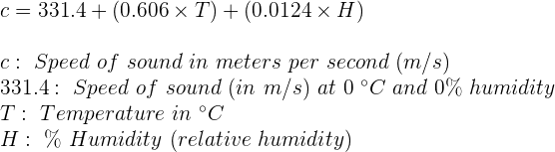

In the equation above, it’s clear that temperature has the largest effect on the speed of sound. Humidity does have some influence, but it’s much less than the effect of temperature.

# Design

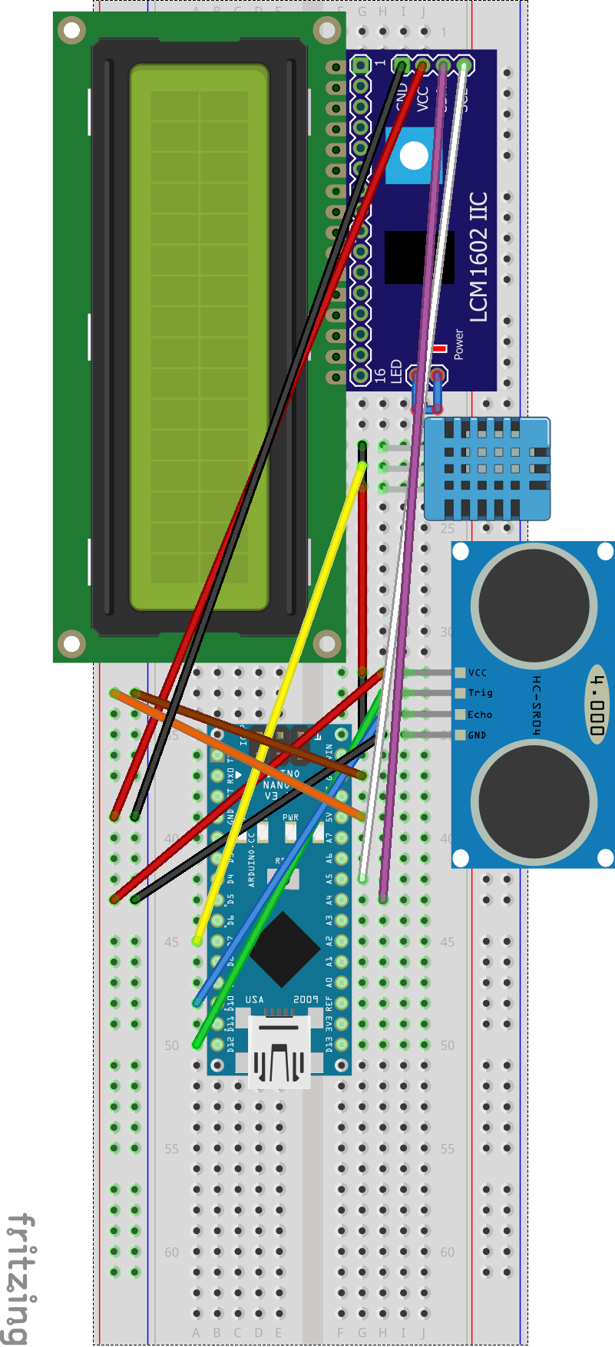

The device is powered by a single 9V battery with the positive terminal connected to the VIN pin and the negative terminal connected to the GND pin.

**The following table shows the connections you need to make[3] :**

|  |  |
| --- | --- |
| **Ultrasonic Sensor HC-SR04** | **Arduino** |
| VCC | 5V |
| Trig | Pin 11 |
| Echo | Pin 12 |
| GND | GND |

**The pin connections of the LCD display to the Arduino are given below[4] :**

LCD Pin - - - - - -LCD PIN NAME - - - - - - - Arduino Pin

1 - - - - - - - - - - - - - - VSS - - - - - - - - - - -- - - - -GND

2- - - - - - - - - - - - - - -VDD- - - - - - - - - - - - - - - +5V

3- - - - - - - - - - - - - - - V0- - - - - - - - - - - - - -Pot centre Pin

4- - - - - - - - - - - - - -- -RS- - - - - - - - - - - - - - - -pin 10

5- - - - - - - - - - - - - - - RW- - - - - - - - - - - - - - - -- GND

6- - - - - - - - - - - - - - - -E- - - - - - - - - - - - - - - - - pin 9

7- - - - - - - - - - - - - - - -DB0- - - - - - - - - NOT CONNECTED

8- - - - - - - - - - - - - - - -DB1- - - - - - - - - NOT CONNECTED

9- - - - - - - - - - - - - - - -DB2- - - - - - - - - NOT CONNECTED

10- - - - - - - - - - - - - - - -DB3- - - - - - - - NOT CONNECTED

11- - - - - - - - - - - - - - - -DB4- - - - - - - - - - - - - - - -Pin 5

12- - - - - - - - - - - - - - - -DB5- - - - - - - - - - - - - - - -Pin 4

13- - - - - - - - - - - - - - - -DB6- - - - - - - - - - - - - - - -Pin 3

14- - - - - - - - - - - - - - - -DB7- - - - - - - - - - - - - - - -Pin 2

15- - - - - - - - - - - - - - - -Backlight LED +V- - - - - - +5 Volt

16- - - - - - - - - - - - - - - -Backlight LED GND - - -- - - -GND

# Pre-requirements for the Project with list and Cost

|  |  |  |
| --- | --- | --- |
| **Sr. NO.** | **Particular** | **Cost.** |
| 1 | Arduino Nano | 355/- |
| 2 | HC-SR04 sensor | 152**/-** |
| 3 | DHT-11 sensor | 220/- |
| 3 | 16x2 LCD (JHD162A) | 182/- |
| 4 | Breadboard + Jumper wires | 209/- |
| 5 | I2C interface | 169/- |
| **Total Cost** | | **1231/-** |

# Expected Outcomes and Conclusions:

The device connected for this mini-project should be able to measure the distance between two points (i.e. the sensor and an object/obstacle) with a range of 2-400 cm and an accuracy of ±3mm[1]. The distance measured should also be displayed clearly on the LCD display connected to the device. The device should be handy and have practical use.

If these outcomes are met, the device will be considered successful as it has achieved all the objectives as envisioned by the developers of this mini-project and imparted a great deal of knowledge about Electronics to everyone involved in this endeavor.

# Acknowledgement:

I have put in the possible effort needed to complete this mini-project. However, it would not have been possible without the kind support and help of many people. I would like to extend my sincere thanks to all of them.

I am highly indebted to our Physics professor DR. SANDIP DHOBALE for their guidance and constant supervision as well as for providing necessary information regarding the project & also for their support in completing the project.

I also would like to express my gratitude towards our Principal DR. MUKESH PATIL to provide us an opportunity for doing this project & for his kind co-operation and encouragement which helped me in the completion of this project.

I would like to express my special gratitude and thanks to all my teachers for giving me so much attention and time.

My thanks and appreciations also go to my group members for helping in developing this mini-project and all the people who have willingly helped me out with their abilities.

**References and Bibliography:**

1. <http://www.circuitbasics.com/>
2. <https://maker.pro/>
3. <https://randomnerdtutorials.com/>
4. [www.instructables.com](http://www.instructables.com)
5. <https://create.arduino.cc/>
6. <https://en.wikipedia.org/>
7. <https://www.youtube.com/>